Experiment No. 4
K-Nearest Neighbors (KNN) Classification
Name : Rishabh Ramani
Class : D15B
Roll No : 48
Batch : B

Aim
To implement K-Nearest Neighbors (KNN) algorithm for classification using a real-world dataset.

1. Dataset Source
Dataset Name: ICC Cricket World Cup 2023 Dataset
Source: https://www.kaggle.com/datasets/maulikpatel1930/cricket-world-cup-2023

2. Dataset Description
Key Features:
- Match details (date, city, stadium)
- Team details (Team 1, Team 2, Toss Winner)
- Match statistics (runs, wickets, overs, run rate)

Dataset Characteristics:
- Mixed numerical and categorical attributes
- Small dataset size
- High dimensionality
- Requires encoding and normalization before applying KNN

3. Mathematical Foundation of KNN
K-Nearest Neighbors is a non-parametric, instance-based, and lazy learning algorithm.

Distance Metric (Euclidean Distance):
d(x, y) = √(Σᵢ (xᵢ - yᵢ)²)

Formula:
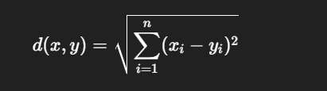

Where x is the test data point, y is a training data point, n is the number of features.

Classification Rule:
ŷ = majority class among K nearest neighbors
The class most frequently occurring among the K nearest matches determines the predicted winning team.

4. Algorithm Limitations
- Computationally expensive at prediction time (searches entire training set)
- Sensitive to feature scaling
- Does not work well with high-dimensional data
- Choice of K greatly affects performance
- Not suitable for very large datasets

5. Methodology / Workflow
- Load the ICC Cricket World Cup 2023 dataset
- Handle missing or inconsistent values
- Encode categorical attributes such as team names and venues
- Normalize numerical features to ensure equal distance contribution
- Split the dataset into training and testing sets
- Apply the KNN classifier
- Predict match outcomes
- Evaluate model performance

Workflow: Dataset → Preprocessing → Feature Scaling → KNN Classifier → Prediction → Evaluation

6. Performance Analysis
Evaluation Metrics Used:
- Accuracy
- Precision
- Recall
- F1-score
- Confusion Matrix

Output:
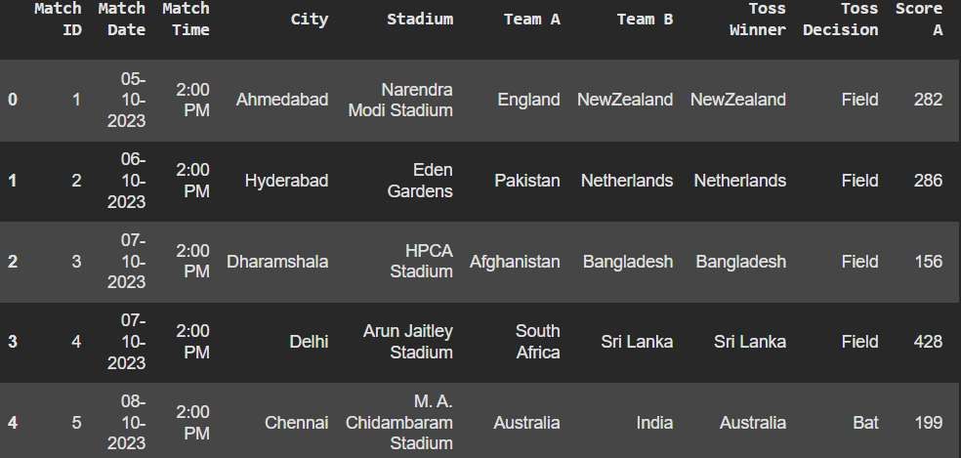

7. Hyperparameter Tuning
Parameters Tuned:
- Number of neighbors (K)
- Distance metric (Euclidean, Manhattan)
- Weighting scheme (uniform vs. distance)
Method: Cross-validation to find optimal K

Conclusion
KNN is a simple yet effective algorithm for classification tasks. When applied to the CWC 2023 dataset, proper feature encoding and normalization were essential for good results. The choice of K and distance metric significantly impacts model accuracy.

